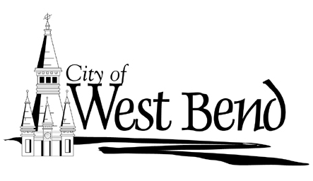

May 2, 2019

Dear City of West Bend Property Owner;

On Monday June 24^{th,} 2019 the City of West Bend and the Downtown West Bend Association will again host the Tour of America’s Dairyland Bike Race on several city streets surrounding the Downtown area. Attached to this letter are two race course routing maps and the streets that will be closed for the duration of the race day which is scheduled from 12:30 P.M. to 9:00 P.M. on Monday June 24th. Note: Some roads will begin closing at 10:00 A.M. and will reopen by 9:40 P.M.

Map #1 indicates the actual race area that will be closed entirely and will only allow controlled foot traffic access periodically in-between scheduled races, but there will be virtually no “drive-in/drive-out” access within the race routing boundaries.

Map #2 is the outer perimeter which will be posted with “No Thru Traffic” and “Road open to Businesses” signage, and manned by police staff. Residents affected by this outer perimeter will be able to get to homes and customers to businesses.

The West Bend Police Department will be staffing each intersection to maintain the overall safety of the event and surrounding areas. The assigned officers and staff will work to provide as much access as possible to affected businesses and residences while maintaining the safety of the participants and spectators.

TOAD is the largest competitive cycling event in the USA. The organization is entering its 11th year of racing in Wisconsin, with multiple sponsors including the Kwik Trip, TREK, and Collectivo Coffee. Local Sponsors include Delta Defense and Cedar Crest Ice Cream. The TOAD tour stops in a different city each day during the annual 11-day tour and attracts more than 6,000 competitive bikers and thousands of spectators to each city. In 2019, TOAD Bike races are scheduled for Grafton, Wauwatosa, Shorewood, East Troy, Janesville, Waukesha, and Bay View.

If you would like additional information about the street closures, please contact the Downtown West Bend Association at
(262) 338-3909 or email at anna@downtownwestbend.com or City Tourism and Events Coordinator, Jackie at (262)-335-5080, or email at jmwbprf@ci.west-bend.wi.us.

Regards,
Jackie Maynard
Tourism & Special Events
City of West Bend
1115 S. Main Street
West Bend, WI 53095
jmwbprf@ci.west-bend.wi.us
(262) 335-5086 – office

MAP #2 (Yellow Highlight= Race Course Red Lines = outer perimeter “No Thru Street” traffic control)
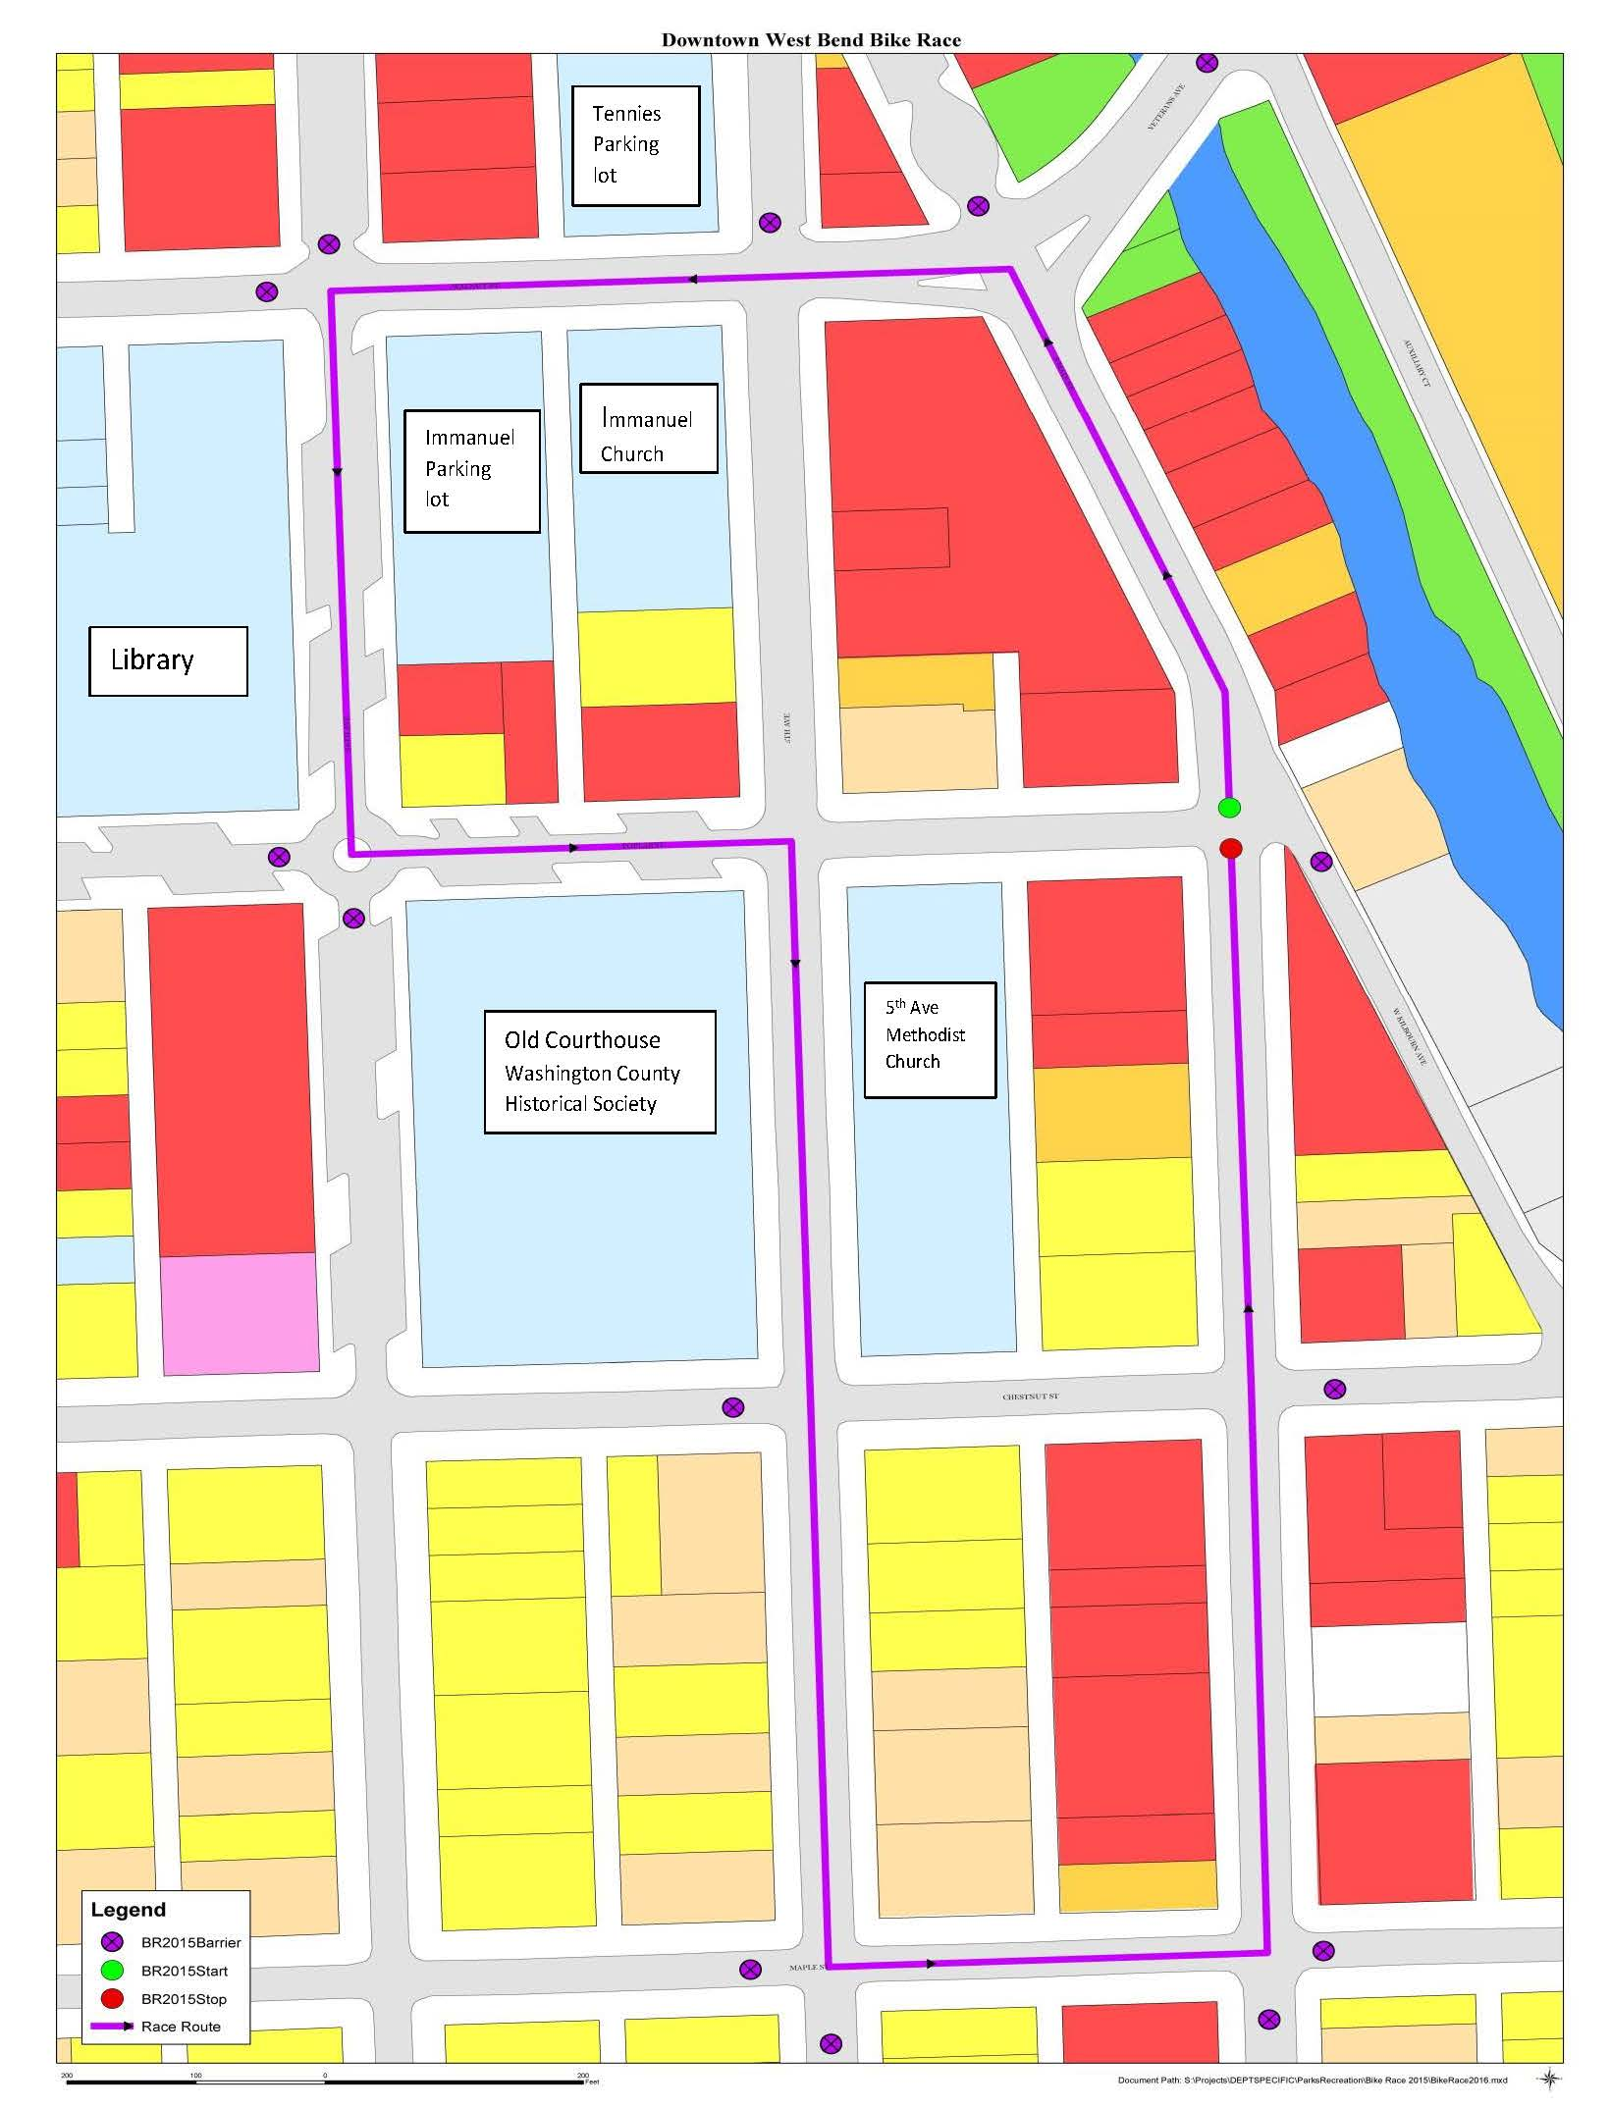
Westbury Bank
MAP #1 (Purple Lines= Race Course Purple Circles = Race course barricades Red & Green Dots= Start/Finish line)

