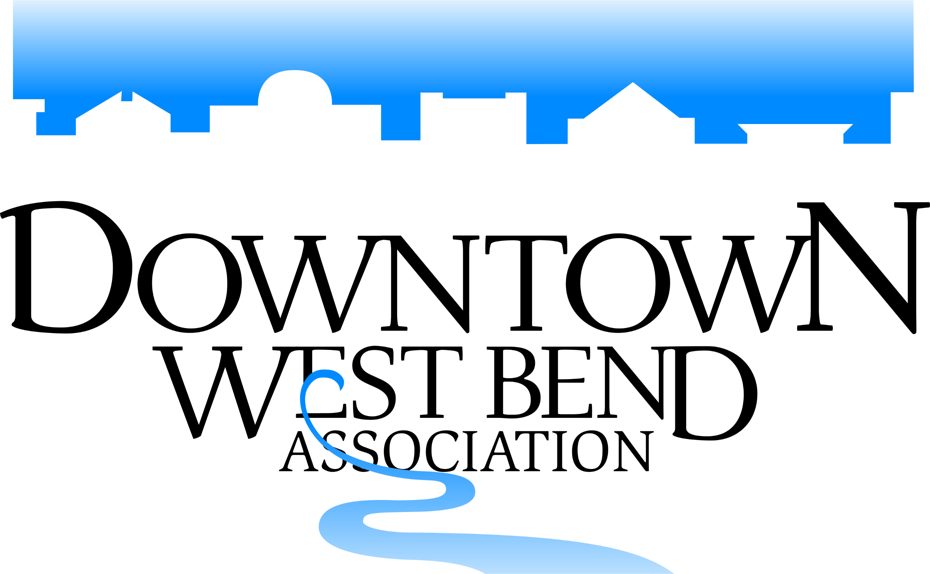
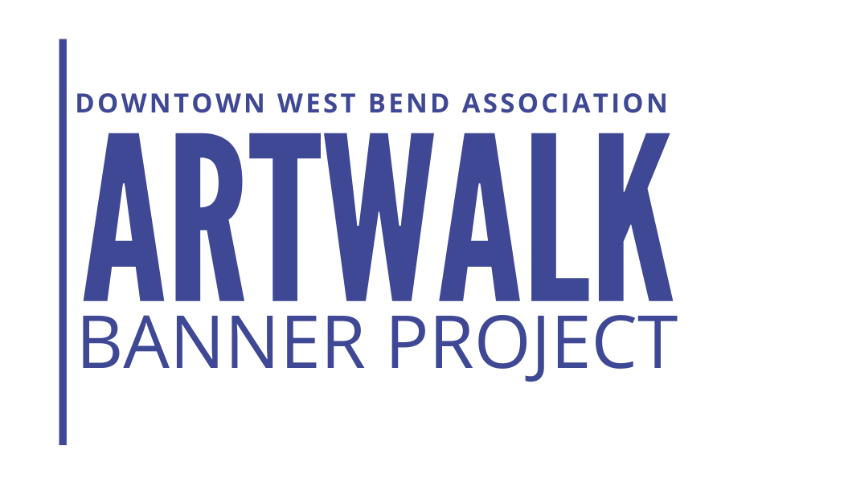

Sponsorship levels
YES! I would like to support the ARTWALK Banner Program
For more information https://www.downtownwestbend.com/artwalk.html

_____I would like to be the AWARD sponsor ($500.00)
Helps to support the artists with a cash award – First place, Second place & Student Award
- Be a Judge at the Grand Galley Opening select artist winners (optional)
- Opportunity to speak at the Grand Gallery Opening (optional – but we would love you there)
- Business name permanently adhered to 1 Artist banners ($100.00 Value)
- Name & logo recognition on the DWBA website & social media – Award Sponsor
- Name & logo listed in the custom brochure – Award Sponsor
- Name & Logo listed on signage as Award Sponsor
- Added to all the Artwalk Banner Project marketing on website, print & social media.

_____ I would like to be the EVENT sponsor ($250.00) Provide Entertainment & Decorations
- Business name permanently adhered to 1 Artist banners ($100.00 Value)
- Name & logo recognition on the DWBA website & social media
- Name & logo listed in the custom brochure.
- Name & Logo listed on signage as Major Event sponsor.
- Added to all the Artwalk Banner Project marketing on website, print & social media.

_____ I would like to be the Banner sponsor ($100.00) Support an Artist Banner
- Company name permanently adhered to the artist banner.
- Name recognition on the DWBA website.
- Name listed in the custom brochure.

_____ I would like to donate an appetizer platter – Provide appreciation appetizers or sweets for the artists & guests.
- Name recognition on the DWBA website.
- Name listed on signage at event.
_____ Extra banners sponsoring ($100 per banner)
_____ Total Sponsorship Cost

Business Name: _________________________________ Contact Name: _____________________________
Mailing Address: __________________________________________________________________________
Phone: ____________________________ Email: ____________________________________
Website: _____________________________________________________________________

I/We would like to Volunteer to help with this event or planning of the event: Yes or No
The DWBA will contact you with volunteer options.

Please fill out & return this form, the DWBA will invoice after this form is received.
gena@downtownwestbend.com |262-338-3909

Thank you, for your support of the ArtWalk Banner Project, the community, and Artists.

