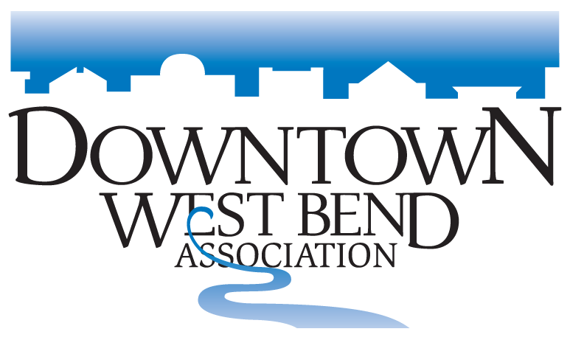
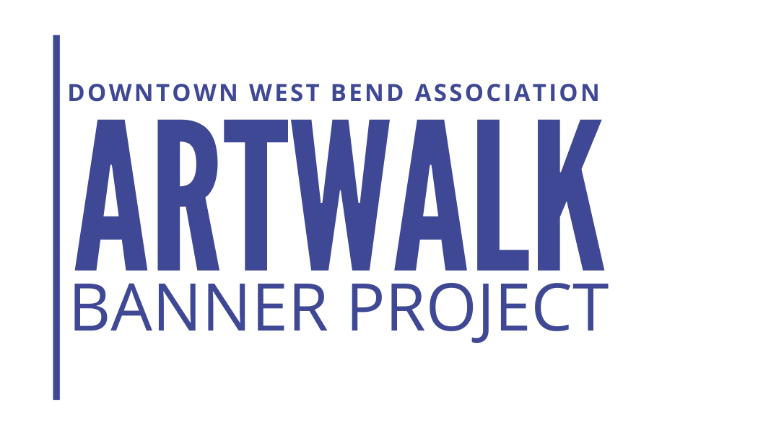

I would like to volunteer for the Artwalk Banner Project

Contact Name: ______________________________________________________________

Phone: ____________________________ Email: ____________________________________

Website: _____________________________________________________________________

I am interested in Volunteering my talents in these main areas:
Circle Yes or no

- As a Committee Member: Whole event all aspects – Meet to discuss details & enhance event, help with banners, assist at the Grand Gallery Open: Yes No

- Hang Banners (May 17th Time TBD): Yes No

- Remove banners (October 25th Time TBD): YES No

- Assist at the Grand Gallery Opening (May 6th) Between 3:00pm & 7:00pm: Yes No

_______________________________________________________________________________________

This form is a guideline if you have additional talents & would like to
be involved please give Gena a call
Office: 262-338-3909 Cell: 262-305-0681
Please email this form to gena@downtownwestbend .com

Meeting location:
Downtown West Bend Association
120 N. Main Street Suite 170
West Bend, WI 53095

Thank you in advance for your support of the ArtWalk Banner Project, the artists, our community
and Downtown West Bend Association all appreciate it.

